3.41: a) , south of east.
b) 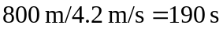.
c) 

